**Performance Comparison**

In this project, we implemented six different machine learning models: KNN and SVM with different parameters to identify three different actions: picking up, throwing and eating. To compare the performance of each model, we tested all three actions 20 times and listed the results below:

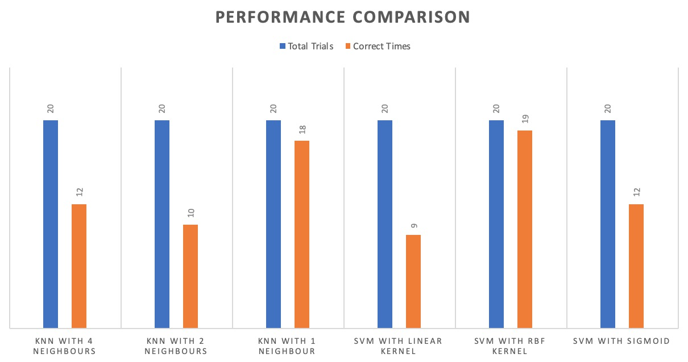

Figure 1

The figure 1 illustrates 6 different conditions with same DSID: KNN with 4 neighbors, KNN with 2 neighbors, KNN with 1 neighbor, SVM with linear kernel, SVN with RBF kernel and SVM with sigmoid kernel. Based on the figure, we can see that SVM with RBF kernel perform best. It identifies 19 out of 20 actions correctly, which means most of the time our actions will be identified correctly. KNN with only 1 neighbor also has a good result, but it still performs worse than SVM with RBF kernel. Therefore, we will use SVM with RBF kernel to identify actions in the game.